**Spatial Temporal Analysis and Fire Precision Support System for Detection, Classification and Acreage Estimation**

**M.Sc. – Agriculture Analytics, Semester - II**

 Prepared at

ISO 9001:2008

ISO 27001:2013

CMMI LEVEL-5

**Bhaskaracharya National Institute for Space Applications & Geo-informatics**

**Ministry of Electronics and Information Technology, Govt. of India.**

**Gandhinagar**

**Prepared By**

**Sanket Gondaliya Smit Gondaliya**

**Divya Prajapati Jayesh Patel**

**Group ID No.: 24SH1 Group ID No.: 24SH1**

**Guided By: External Guide:**

**Dr. Srimanta Mandal** **Shri Vijay Singh**

**Guide & Associate Professor Dr. Yagnesh Vyas**

**DAIICT, Gandhinagar. Project Director**

**BISAG- N, Gandhinagar.**

**SUBMITTED TO**

**Dhirubhai Ambani Institute of Information and Communication Technology, Gandhinagar**



 Bhaskaracharya National Institute for Space Applications and Geo-informatics

MeitY, Government of India

Phone: 079 - 23213081 Fax: 079 - 23213091

ISO 9001:2008

ISO 27001:2013

CMMI LEVEL-5

ISO 27001:2005

E-mail: info@bisag.gujarat.gov.in, website: [https://bisag-n.gov.in/](https://bisag-n.in/)

**CERTIFICATE**

*This is to certify that the project report compiled by* ***Mr. Sanket Gondaliya, Ms. Divya Prajapati, Mr. Smit Gondaliya, and Mr. Jayesh Patel*** *students of 2nd Semester* ***M.Sc. Agriculture Analytics*** *from* ***Dhirubhai Ambani Institute of Information and Communication Technology, Gandhinagar*** *have completed their Summer**internship project satisfactorily. To the best of our knowledge this is an original and bonafide work done by them. They have worked on Analysis of “****Spatial Temporal Analysis and Fire Precision Support System for Detection, Classification and Acreage Estimation****”, starting from May 15th, 2024 to June 30th, 2024.*

*During their tenure at this Institute, they were found to be sincere and meticulous in their work. We appreciate their enthusiasm & dedication towards the work assigned to them.*

*We wish them every success.*

**Shri Vijay Singh Punit Lalwani**

**Dr.** **Yagnesh Vyas CISO,**

**Project Director**, **BISAG- N, Gandhinagar**

**BISAG- N, Gandhinagar**



**Dhirubhai Ambani Institute of Information and Communication Technology, Gandhinagar-** **382007**

**CERTIFICATE**

*This is to certify that the 2nd Semester Summer Internship Project entitled "* ***Spatial Temporal Analysis and Fire Precision Support System for Detection, Classification and Acreage Estimation****” has been carried out by* ***Mr. Sanket Gondaliya, Ms. Divya Prajapati, Mr. Smit Gondaliya, and Mr. Jayesh Patel*** *under We guidance in fulfilment of the degree of Master of Science in* *Agriculture Analytics (2nd Semester) of Dhirubhai Ambani Institute of Information and Communication Technology, Gandhinagar during the academic year 2023-2024*

**Guide**

**Dr. Srimanta Mandal**

**Guide & Associate Professor**

**DAIICT, Gandhinagar.**

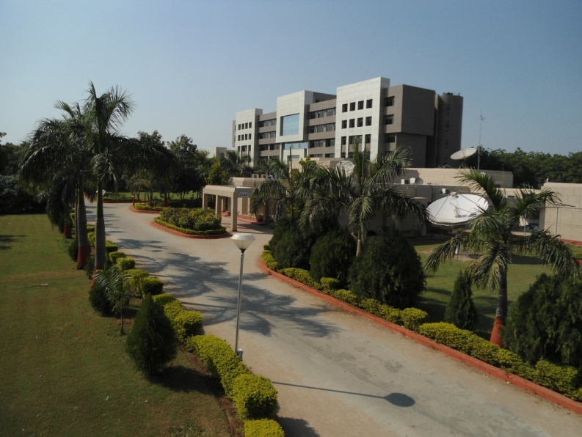About BISAG- N

ABOUT THE INSTITUTE

Modern day planning for inclusive development and growth calls for transparent, efficient, effective, responsive and low cost decision making systems involving multi-disciplinary information such that it not only encourages people's participation, ensuring equitable development but also takes into account the sustainability of natural resources. The applications of space technology and Geo–informatics have contributed significantly towards the socio-economic development. Taking cognizance of the need of geo-spatial information for developmental planning and management of resources, the department of Ministry of Electronics and Information Technology, Government of India, established "Bhaskaracharya National Institute for Space Applications and Geo-informatics" (BISAG- N). BISAG- N is an ISO 9001:2008, ISO 27001:2005 and CMMI: 5 certified institute. BISAG- N which was initially set up to carryout space technology applications, has evolved into a centre of excellence, where research and innovations are combined with the requirements of users and thus acts as a value added service provider, a technology developer and as a facilitator for providing direct benefits of space technologies to the grass root level functions/functionaries.

BISAG- N's Enduring Growth

Since its foundation, the Institute has experienced extensive growth in the sphere of Space technology and Geo-informatics. The objective with which BISAG- N was established is manifested in the extent of services it renders to almost all departments of the State. Year after year the institute has been endeavouring to increase its outreach to disseminate the use of geo-informatics up to grassroots level. In this span of nine years, BISAG- N has assumed multi-dimensional roles and achieved several milestones to become an integral part of the development process of the Gujarat State.

|  |  |  |
| --- | --- | --- |
| BISAG- N Journey | 2003-0403.JPG | Gujarat SATCOM Network |
| 2007-08DSC_2461.JPG | Centre for  Geo-informatics  Applications |
| 2010-11D:\Bharat Work 2011\BISAG-2011\BISAG Broacher 2011\DSC_9696-OK.JPG | Academy of Geo-informatics for Sustainable Development |
| 2012-13 | A full-fledged Campus |

Activities 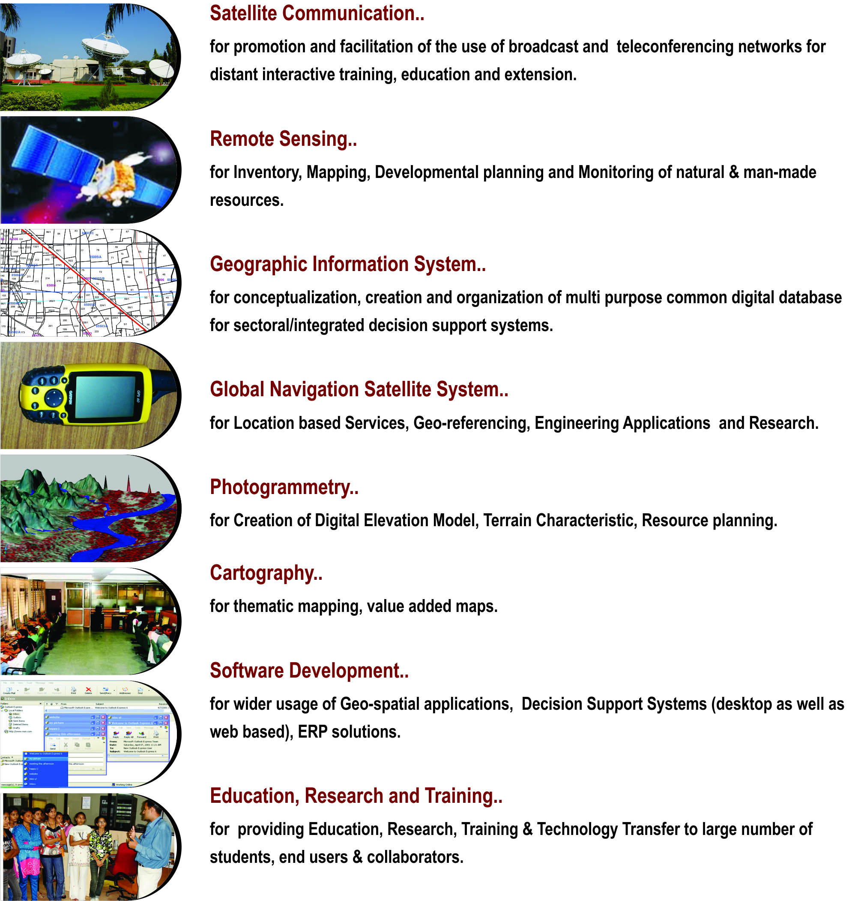

Applications of Geospatial Technology for Good Governance: Institutionalization

Through the geospatial technology, the actual situation on the ground can be accessed. The real life data collected through the technology forms the strong foundation for development of effective social welfare programs benefiting directly the grass root level people. The geospatial data collected by the space borne sensors along with powerful software support through Geographic Information System (GIS), the vital spatio-temporal maps, tables, and various statistics are being generated which feed into Decision Support System (DSS).

A multi-threaded approach is followed in the process of institutionalization of development of such applications. The 5 common threads which run through all the processes are: *Acceptability, Adaptability, Affordability, Availability and Assimilability*.

These are the “Watch Words” which any application developer has to meet. The “acceptability” addresses the issue that the application developed has met the wide acceptability among the users departments and the ultimate end beneficiary by way of providing all necessary data and statistics required. The “affordability” addresses the issue of the application product being cost effective. The “availability” aspect looks into aspect of easily accessible across any platform, anywhere and anytime. The applications should have inbuilt capability of easy adaptability to the changing spatio- and temporal resolutions of data, new aspects of requirements arising from time to time from users. The assimilability aspect ensures that the data from various sources / resolutions and technologies can be seamlessly integrated.

|  |  |
| --- | --- |
| **ACCEPTABILITY** | * + - * Problem definition by users |
|  | * Proof of Concept development without financial liability on users |
|  | * + - * Execution through collaboration under user’s ownership |
| **ADOPTABILITY** | * + - * + Applications as per present systems & database |
|  | * + - * Maximum Automation |
|  | * + - * Minimum capacity building requirement at the user end |
| **AFFORDABILITY :** | * + - * Multipurpose geo-spatial database, common, compatible, standardized (100s of layers) |
|  | * + - * In house developed/open source software |
|  | * + - * Full Utilization of available assets |
| **AVAILABILITY:** | * + - * + Departmental /Integrated DSS |
|  | * + - * + Desired Product delivery anytime, anywhere in the country |
| **ASSIMILABILITY** | * + - * + Integration of Various technologies like RS, GIS, GPS, Web MIS, Mobile etc. |

Organizational Setup

The Institute is responsible for providing information and technical support to different Departments and Organizations. The Governing Body and the Empowered Executive Committee govern the functioning of BISAG- N. The Institute is registered under the Societies Registration Act 1860. Considering the scope and extent of activities of BISAG- N, its organizational structure has been charted out with defined functions.

Organizational Setup of BISAG- N

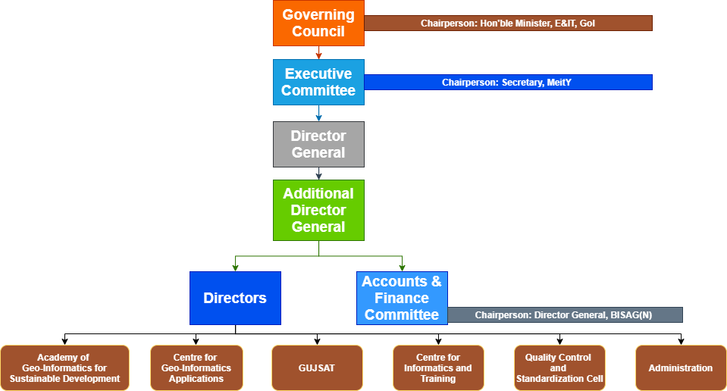

Governing Body

For smoother, easier and faster institutionalization of Remote Sensing and GIS technology, decision makers of the state were brought together to form the Governing Body. It is the supreme executive authority of the Institute. The Governing Body comprises of ex-officio members from various Government departments and Institutes.

* Hon’ble Minister of Electronics and Information Technology Chairperson (Ex-Officio)
* Hon’ble Minister of State Electronics and Information Technology ………………Deputy Chairperson (Ex-Officio)
* Secretary of Government of India: Ministry of Electronics and Information Technology............................................ Executive Vice Chairperson (Ex-Officio)
* Chief Executive Officer, Niti Aayog ………………Member (Ex-Officio)
* Chairman, Indian Space Research Organization ………………Member (Ex-Officio)
* Secretary to Government of India: Department of Science and Technology ………………Member (Ex-Officio)
* Additional Secretary to Government of India: Ministry of Electronics and Technology …………Member (Ex-Officio)
* Chief Secretary to Government of Gujarat ………………Member (Ex-Officio)
* President & Chief Executive Officer, National e-Governance Division, Ministry of Electronics
* and Information Technology ……………… Member (Ex-Officio)
* Financial Advisor to Government of India: Ministry of Electronics and Information Technology …Member (Ex-Officio)
* Distinguished Professionals from the GIS field-Three (3) (To be nominated by the Chairperson)
* Director-General, Bhaskaracharya National Institute for Space Application and Geo-Informatics {BISAG(N)} Member Secretary (Ex-Officio)

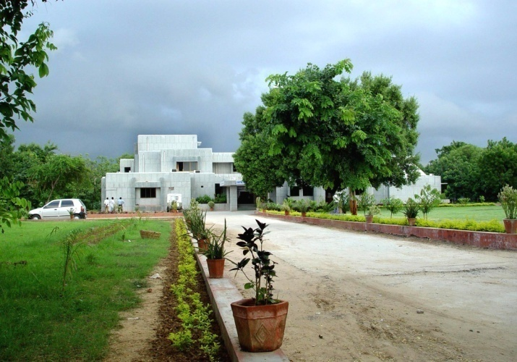Centre  
for  
Geo-informatics Applications

Introduction

The objective of this technology group is to provide decision support to the sectoral stake holders through scientifically organized, comprehensive, multi-purpose, compatible and large scale (village level) geo-spatial databases and supporting analytical tools. These activities of this unit are executed by a well-trained team of multi-disciplinary scientists. The government has provided a modern infrastructure along with the state-of-the-art hardware and software. To study the land transformation and development over the years, a satellite digital data library of multiple sensors of last twenty years has been established and conventional data sets of departments have been co-registered with satellite data. The geo-spatial databases have been created using conventional maps, high resolution satellite 2D and 3D imagery and official datasets (attributes).The geo-spatial databases include terrain characteristics, natural and administrative systems, agriculture, water resources, city survey maps, village maps with survey numbers, water harvesting structures, water supply, irrigation, power, communications, ports, land utilization pattern, infrastructure, urbanization, environment data, forests, sanctuaries, mining areas, industries. They also include social infrastructure like the locations of schools, health centres, institutions, aganwadies, local government infrastructure etc. The geospatial database of nagar-palikas includes properties and amenities captured on city and town planning maps with 1000 GIS layers. Similar work for villages has been initiated as a pilot project.

The applications of space technology and geo-informatics have been operational in almost all the development sectors of the state. Remote sensing and GIS applications have provided impetus to planning and developmental activities at grass root level as well as monitoring and management in various disciplines.

The GIS based Applications Development

The GIS software is a powerful tool to handle, manipulate and integrate both the spatial and non-spatial data. The GIS system operates on the powerful backend data base and Sequential Query Language (SQL) to inquiry the data bases. It has the capability to handle large volume of data and process to yield values of parameters which can be input to very important government activity as Decision Support System (DSS). Its mapping capabilities help the users and specialists in generating single and multi-theme wise maps.

The GIS based applications development has been institutionalized in BISAG- N. This process can be listed as (Refer Figure for Details)

* Making the users aware of the GIS capabilities through introductory training programme and by exposing to already developed projects as success stories.
* Helping the users in defining the GIS based projects.
* Digitizing the data available with the users and encouraging them to collect any additional data as may be required.
* Generating the appropriate data bases with the full involvement of the users following the data bases standards

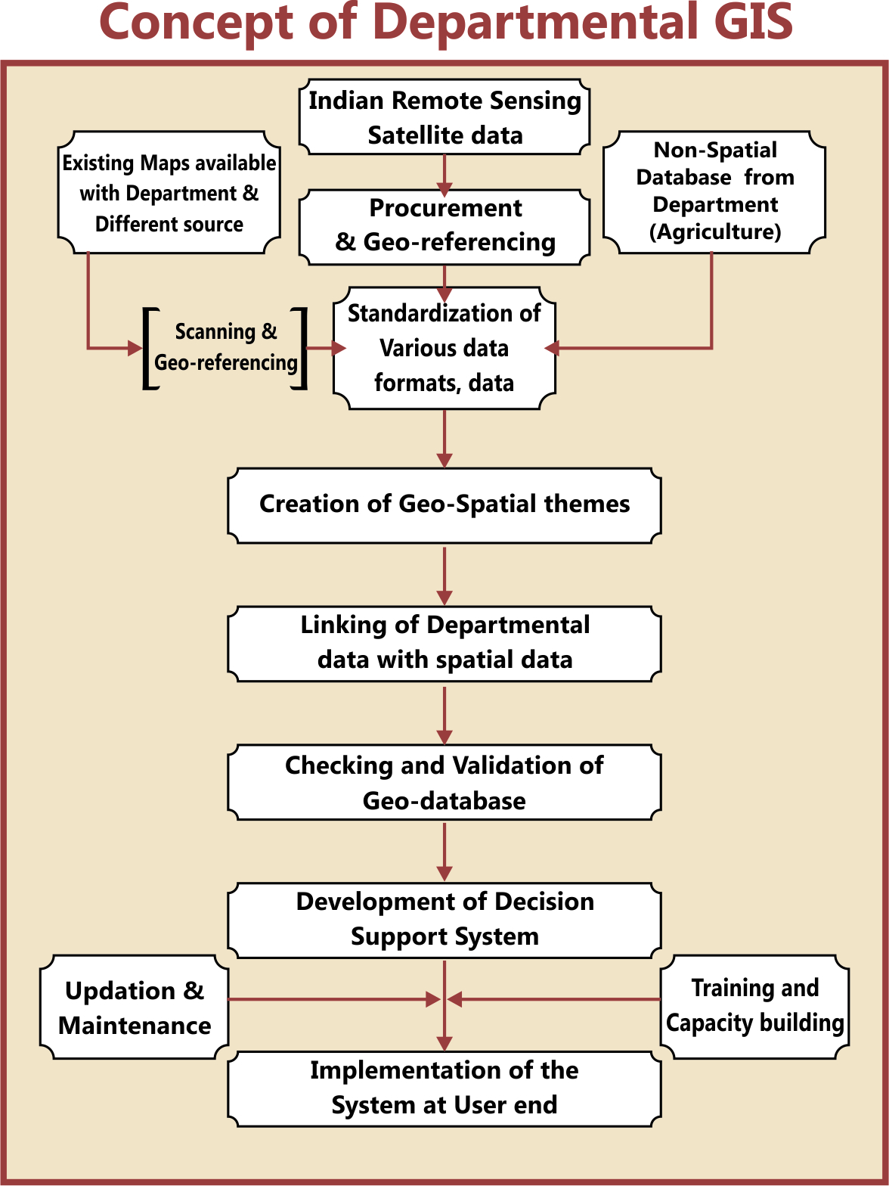

Remote Sensing and GIS Sectoral Applications:

Geo-informatics based Irrigation Management and Monitoring System

* The Geo-spatial information system for Irrigation water Management and Monitoring system for command areas in Sardar Sarovar Narmada Nigam Limited (SSNL) has been developed. Satellite image-based Irrigation monitoring system has been developed in GIS. From the multi-spectral Satellite images of every month, the irrigated areas were extracted.
* The irrigated area were overlaid on the geo-referenced cadastral maps and the statistics of area irrigated has been estimated.
* The user friendly Customized Decision Support System (DSS) has been developed.

**Preparation of DPR of Par–Tapi-Narmada Link using Geo-informatics for National Water development Agency (NWDA)**

* The main objective of Par–Tapi-Narmada Link project is to divert surplus water available in west flowing rivers of south Gujarat and Maharashtra for utilization in the drought prone Saurashtra and Kachcha. On the request from NDWA, preparation of various maps for proposed DPR work was undertaken by the BISAG- N. Land use and submergence maps of proposed dams along with its statistics have been prepared by the BISAG- N. The detailed work consisted of generation of Digital Elevation Model (DEM), contour generation, Land use mapping, forest area generation of submergence extent at different levels etc.

**Agriculture**

**District and Village-level Crop Inventory**

* Remote Sensing (RS) based Village-level Crop Acreage Estimation at was taken up in two villages of Anand and Mehsana districts of Gujarat state. The major objective of this study was to attempt village-level crop inventory during two crop seasons of Kharif (monsoon season) and Rabi (winter season) using single-date Indian Remote Sensing (IRS) LISS-III and LISS-IV digital data of maximum vegetative growth stage of major crops during each season.
* District-level crop acreage estimation during three cropping seasons namely Kharif, Rabi and Zaid (summer) seasons was also carried out in all the 26-districts of Gujarat State. Summer crop acreage estimation Gujarat State was carried out during 2012.

**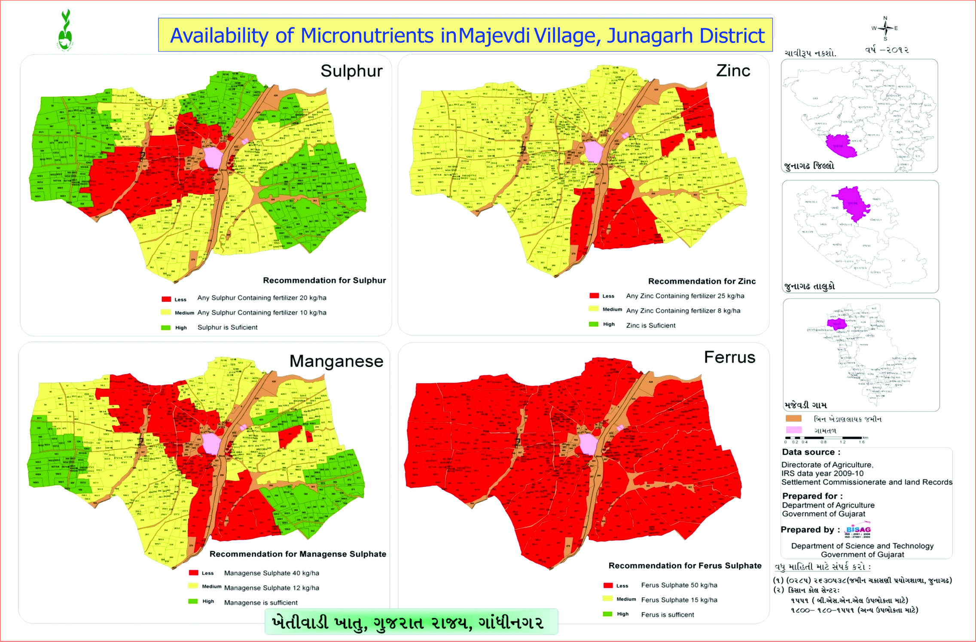Spatial Variability Mapping of Soil Micro-Nutrients**

* The spatial variability of soil micro-nutrients like Fe, Mn, Zn and Cu in various villages of different districts, Gujarat state was mapped using geo-informatics technology. The major objectives of this study were i) to quantify the variability of Mn, Fe, Cu and Zn concentration in soil; ii) to map the pattern of micro-nutrient variability in cadastral maps, iii) suggest proper application of micro-nutrients based on status of deficiency for proper crop management and iv) preparation of village-level atlases showing spatial variability of micro-nutrients.

Geo-spatial Information System for Coastal Districts of Gujarat

* The project on development of Village-level Geo-spatial Information System for Shrimp Farms in Coastal Districts of Gujarat, was taken with major objective of development of Village-level Geo-spatial Information System for Shrimp/Scampi areas using Remote Sensing (RS) and GIS. This project was sponsored by the Marine Products Export Development Authority (MPEDA), Ministry of Commerce & Industry, Government of India for scientific management of Scampi farms in the coastal  districts which can help fishermen to better their livelihood and increase the economic condition on sustainable basis. The customized query shell was developed using the open source software for sharing the information amongst the officers from MPEDA and potential users. This has helped the farmers to plan their processing and marketing operations so as to achieve better remunerations.

Environment and Forest

****

**Mapping and Monitoring of Mangroves in the Coastal Districts of Gujarat State**

* Gujarat Ecology Commission, with technical inputs from the Bhaskaracharya National Institute for Space Applications and Geo-informatics - N (BISAG- N) made an attempt to publish Mangrove Atlas of the Gujarat state. Mangrove atlas for 13-coastal districts with 35-coastal talukas in Gujarat, have been prepared using Indian Remote sensing satellite images. The comparison of mangrove area estimates carried out by BISAG- N and Forest Survey of India (FSI) indicates a net increase in the area under mangrove cover. The present assessment by BISAG- N, has recorded 996.3 sq. km under mangrove cover, showing a steep rise to the tune of 88.03 sq. km. In addition to the existing Mangrove cover, the present assessment also gives the availability of potential area of 1153 sq. km, where mangrove regeneration program can be taken up.

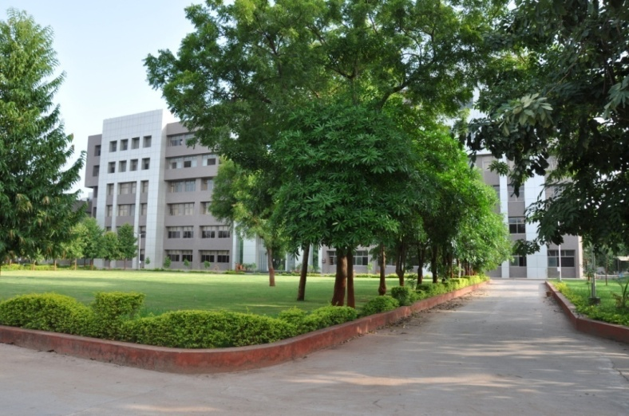Academy   
of  
Geo-informatics

for  
Sustainable

Development

Introduction

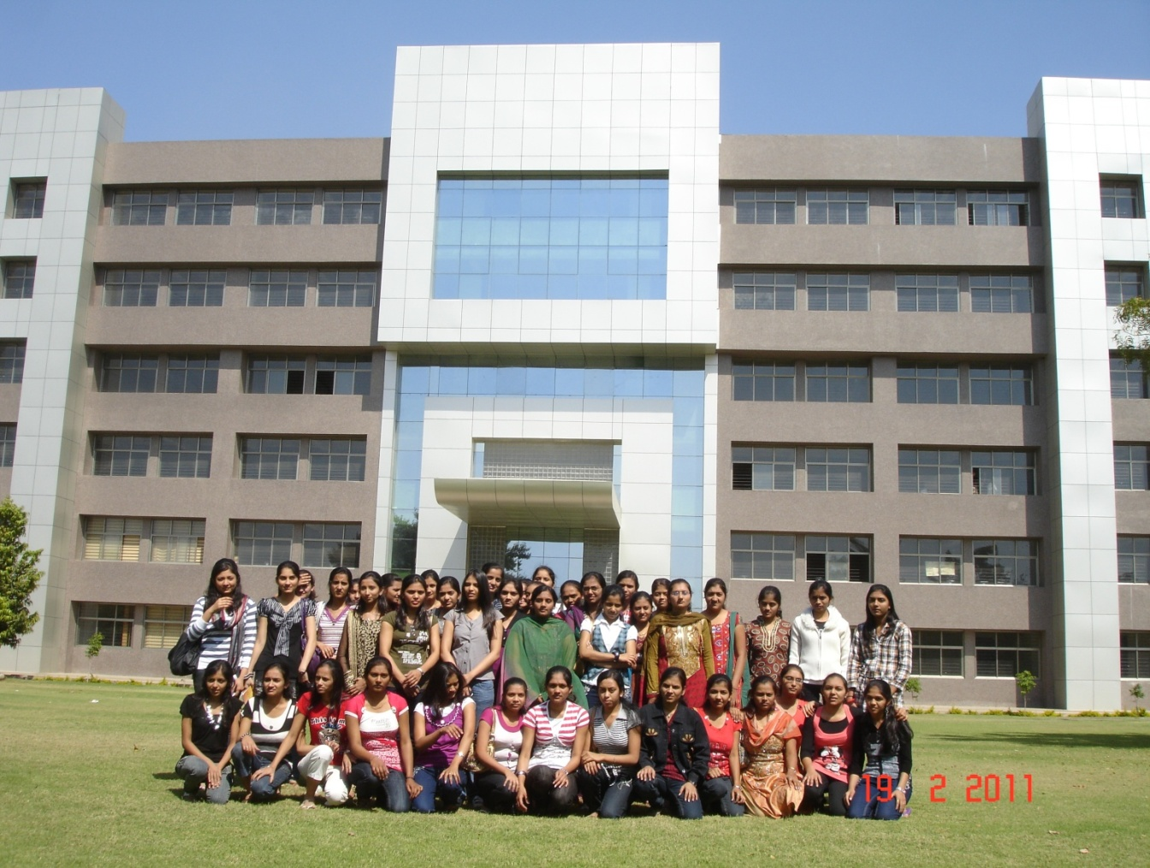

* Considering the requirement of high end research and development in the areas having relevance of geo-informatics technology for sustainable development, a separate infrastructure has been established. In collaboration with different institutes in the state as well as in the country, R&D activities are being carried out in the areas of climate change, environment, disaster management, natural resources management, infrastructure development, resources planning, coastal hazard and coastal zone management studies, etc. under the guidance of eminent scientists.
* Various innovative methodologies/models developed in this academy through the research process have helped in development of various applications. There are plans to enhance R&D activities manifold during coming years.
* This unit also provides training to more than 600 students every year in the field of Geo-informatics to the students from various backgrounds like water resources, urban planning, computer Engineering, IT, Agriculture in the areas of Remote sensing, GIS and their applications.
* This Academy has been established as a separate infrastructure for advanced research and development through following schools:
* School of Geo-informatics
* School of Climate & Environment
* School of Integrated Coastal Zone Management
* School of Sustainable Development Studies
* School of Natural Resources and Bio-diversity
* School of Information Management of Disasters
* School of Communication and Society

During XIIth Five year Plan advance applied research through above schools shall be the main thrust area. Already M. Tech and Ph.D. students of other Universities/ Institutes are doing research in this academy in applied sciences under various collaborative programmes.

M. Tech. Students' Research Programme

The academy started M. Tech. students' research programme in a systematic way. It admitted 11 students from various colleges and universities in Gujarat, Rajasthan and Madhya Pradesh for period of 10 months from August 2011 to May 2012. All the students were paid stipend of Rs. 6000 per month during the tenure. The research covered the following areas:

* Cloud computing techniques
* Mobile communication
* Design of embedded systems
* Aquifer modelling
* Agricultural and Soils Remote Sensing
* Digital Image processing Techniques (Data Fusion and Image Classification).

The research resulted in various dissertations and publications in national and international journals.

• Now nine students, one from IIT, Kharagpur, three from GTU, one from M. S University, Vadodara and four from GU, are undergoing their Ph. D programme. Out of nine, two thesis have been submitted. Two students are from abroad. One each from Vietnam and Yemen. Since then (after approval of research programme from the Governing Body), 200+ papers have been published by the Academy.

**CANDIDATE’S DECLARATION**

We declare that 2nd semester summer internship project report entitled “**Spatial Temporal Analysis and Fire Precision Support System for Detection, Classification and Acreage Estimation**” is our own work conducted under the supervision of the external guide **Dr. Yagnesh Vyas & Shri Vijay Singh** from BISAG-N (Bhaskaracharya National Institute for Space Applications &Geo-informatics). We further declare that to the best of our knowledge the report for this project does not contain any part of the work which has been submitted previously for such project either in this or any other institutions without proper citation.

Candidate 1’s Signature Candidate 2’s Signature

Sanket Gondaliya Divya Prajapati

Group I’d: 24SH1 Group I’d: 24SH1

Candidate 3’s Signature Candidate 4’s Signature

Smit Gondaliya Jayesh Patel

Group I’d: 24SH1 Group I’d: 24SH1

**Submitted To:**

Dhirubhai Ambani Institute of Information and Communication Technology, Gandhinagar.

**ACKNOWLEDGMENT**

We are grateful to **Shri T.P. Singh**, Director General (BISAG-N) for giving us this opportunity to work the guidance of renowned people of the field of GIS Based Portal also providing us with the required resources in the company.

We would like to express our endless thanks to our external guide **Shri Vijay Singh**, **Dr. Yagnesh Vyas** and to Training Cell **Shri Punit Lalwani, Mr. Sidhdharth Patel** at Bhaskaracharya National Institute for Space Applications and Geo-informatics for their sincere and dedicated guidance throughout the project development.

Also, our hearty gratitude to the Coordinator Agriculture Analytics **- Dr. Srimanta Mandal** for giving us encouragement and technical support.

**Sanket Gondaliya. Smit Gondaliya.**

**Divya Prajapati. Jayesh Patel.**

**Group ID No.: 24SH1 Group ID No.: 24SH1**

**ABSTRACT**

Forest fires, or wildfires, are uncontrolled blazes that occur in forests, caused by natural factors or human activities. Annually, forest fires affect about 1-2% of the world's forests, leading to significant ecological and economic damage, as well as contributing to greenhouse gas emissions and climate change.

The study area, located between latitude 19.5°N and longitude 83.3°E, experiences frequent forest fires. These fires are a significant environmental concern, affecting biodiversity and local communities. Annually, approximately 5-10% of the forested area is impacted by fire, leading to loss of vegetation, wildlife habitat, and contributing to air pollution. The frequency and intensity of these fires can be attributed to both natural factors, such as dry conditions and lightning, and human activities, including land clearing and accidental ignitions. Understanding the patterns and causes of forest fires in this region is crucial for developing effective management and mitigation strategies.

This initiative improves forest fire management by utilizing innovative remote sensing and image processing techniques with Sentinel satellite imagery. It detects forest fires by evaluating data from several years prior to and following fire incidents, specifically from 2019 to 2023. The process entails producing NDVI masks to evaluate vegetation health and compute burned area in acres. The system focuses on the important fire-prone months of December to January and June to July, and it offers a comprehensive approach to fire detection, categorization, and acreage estimation. This provides a better knowledge of fire trends and their environmental consequences. By combining spatial and temporal data, the research detects trends and anomalies in fire occurrences, which aids in predictive mod-eling and resource allocation for fire prevention and management. The findings assist better decision-making by forest management authorities, ensuring more effective and prompt responses to forest fires, and ultimately reducing negative environmental and biodiversity impacts.

**Keyword:** NDVI, Forest, Fire, Temporal Analysis, GEE, python

|  |  |  |
| --- | --- | --- |
| **INDEX** | | |
| **Chapter**  **No** | **Description** | **Page**  **No** |
|  | **List of Figures** | **1** |
|  | **List of Tables** | **2** |
|  | **Abbreviations** | **3** |
| **1** | **Introduction** | **4** |
|  | * 1. Overview   1.1.1 Significance of Forests  1.1.2 Detecting Forest Fires  1.1.3 Spectral Analysis  1.1.4 Calculating Burning Area of Forest Fires  1.1.5 Advantages of using remote sensing for forest fire management  1.2 problem statement  1.3 Objective | 4  5  5  5  6  6  7  7 |
| **2** | **Technologies used** | **8** |
|  | 2.1 QGIS  2.2 Google Earth Engine  2.3 Google Looker Studio  2.4 Python | 8  9  10  11 |
| **3** | **Literature survey** | **13** |
| **4** | **Data explanation** | **14** |
|  | 4.1 Data Overview  4.2 Study Area  4.3 Normalized Difference Vegetation Index (NDVI)  4.3.1 What Is NDVI or Normalized Difference Vegetation Index?  4.3.2 How Is NDVI Calculated  4.3.3 A Brief History Of NDVI | 14  15  16  16  16  16 |
| **5** | **Methodology** | **18** |
|  | 5.1 Flowchart  5.2 Data Acquisition  5.3 Pre-processing and Band Selection  5.4 NDVI Calculation  5.5 NDVI Difference Calculation  5.6 Burned Area Identification  5.7 Post-Processing of Burned Areas  5.8 Burned Area Calculation  5.9 Automation and Temporal Analysis | 18  19  19  19  19  20  20  21  21 |
| **6** | **Results & Discussion** | **23** |
|  | 6.1 NDVI Analysis and Burned Area Estimation  6.2 NDVI Maps and Burned Area Masks Year Wise  6.2.1 2019  6.2.2 2020  6.2.3 2021  6.2.4 2022  6.2.5 2023  6.3 Summary of Burned Areas  6.4 Discussion | 23  23  23  24  25  25  26  27  27 |
| **7** | **Conclusion, Limitations and Future work** | **30** |
|  | 7.1 Conclusion  7.2 Limitations  7.3 Future work | 30  31  31 |
|  | **References** | **33** |

|  |  |  |
| --- | --- | --- |
|  | **LIST OF FIGURES** |  |
| **FIGURE NO.** | **TITLE** | **PAGE NO.** |
| 2.1 | QGIS Technology | 8 |
| 2.2 | Google Earth Engine | 9 |
| 2.3 | Looker Studio | 10 |
| 2.4 | Python | 11 |
| 4.1 | Study Area | 15 |
| 4.2 | Spatial Variation of NDVI in the study area | 17 |
| 5.1 | Flowchart | 18 |
| 6.1 | NDVI Maps and Burned Area Masks for The Year 2019 | 24 |
| 6.2 | NDVI Maps and Burned Area Masks for The Year 2020 | 24 |
| 6.3 | NDVI Maps and Burned Area Masks for The Year 2021 | 25 |
| 6.4 | NDVI Maps and Burned Area Masks for The Year 2022 | 26 |
| 6.5 | NDVI Maps and Burned Area Masks for The Year 2023 | 27 |
| 6.6 | Presents A Pie Chart Illustrating the Distribution of Burned Areas Across Different Years | 28 |
| 6.7 | Displays A Line Chart Showing the Trend of Burned Areas Across Different Years | 28 |
| 6.8 | Depicts A Bar Chart That Displays the Distribution of Burned Areas Across Different Years | 29 |

|  |  |  |
| --- | --- | --- |
|  | **LIST OF TABLES** |  |
| **TABLE NO.** | **TITLE** | **PAGE NO.** |
| 4.1 | Details about Sentinel-2 Satellite | 14 |
| 6.1 | Details about the estimated burned areas for each year | 27 |

**ABBREVIATIONS**

**QGIS Quantum geographic information systems**

**NDVI Normalized Difference Vegetation Index**

**NIR Near- Infrared**

**FPSS Fire Precision Support System**

**GEE Google Earth Engine**

**GIS Geographic Information Systems**

**API Application Programming Interface**

**KPIs Key Performance Indicators**

**SWIR Short Wave Infrared**

**MODIS Moderate Resolution Imaging Spectroradiometer**

**NDFI Normalized Difference Fraction Index**

**UAVs Unmanned Aerial Vehicles**

**FIRMS Fire Information for Resource Management System**

**NASA National Aeronautical and Space Administration**

**CHAPTER 1: INTRODUCTION**

* 1. **OVERVIEW**

Forest fires are escalating into a critical global threat, jeopardizing ecosystems, biodiversity, and even human settlements. Climate change and human activities are fueling this crisis, demanding the development of sophisticated management strategies to minimize their devastating impact. Remote sensing technology, particularly through powerful satellite imagery like Sentinel data, has emerged as a game-changer in forest fire monitoring and management.

This innovative research project leverages Sentinel satellite imagery and a powerful tool called the NDVI to create a robust framework for forest fire detection and analysis. NDVI helps generate detailed masks that pinpoint changes in vegetation health, offering a clear distinction between pre-fire and post-fire states. The project will meticulously examine data spanning 2019 to 2023, with a particular focus on the high-risk fire months of December-January and June-July. This comprehensive temporal analysis will provide invaluable insights into forest fire occurrences and their patterns over multiple years.

A pivotal aspect of this project is the development of the FPSS. This cutting-edge system integrates both spatial and temporal data to significantly enhance fire detection, classification, and the estimation of burned areas. By identifying fire patterns and anomalies, the FPSS paves the way for predictive modelling, enabling efficient resource allocation for proactive fire prevention and improved management strategies.

The insights gleaned from this research will be of paramount importance to forest management authorities. It will equip them with the knowledge and tools to respond to forest fires more effectively and in a timely manner. This will ultimately lead to reduced environmental damage, improved protection of forests, and the safeguarding of biodiversity.

This ground breaking project significantly advances the field of forest fire management by integrating advanced remote sensing techniques with a robust temporal analysis. By providing a deeper understanding of fire ecology, it empowers the development of strategic interventions to protect these vital forested areas. This research presents a significant leap forward in our fight against the ever-growing threat of forest fires.

* + 1. **SIGNIFICANCE OF FORESTS**

Forests are vital for our planet's health and our own well-being. Here's a glimpse of their importance:

* **Environmental Benefits:**

**Clean Air:** Forests act as the "lungs of the Earth" by absorbing carbon dioxide and releasing oxygen through photosynthesis.

**Water Regulation:** Forests help regulate the water cycle, preventing soil erosion and floods, and filtering water for human use.

**Biodiversity:** Forests provide crucial habitat for a vast array of plants and animals.

**Climate Change Mitigation**: Forests store large amounts of carbon, helping to combat climate change.

* **Human Benefits:**

**Resources**: Forests provide us with timber, food, medicine, and other resources.

**Livelihoods:** Many communities rely on forests for their livelihoods.

**Recreation:** Forests offer opportunities for recreation and relaxation.

* + 1. **DETECTING FOREST FIRES:**

There are several methods for detecting forest fires, with remote sensing playing a key role:

* **Satellite Imagery**: Satellites can detect fires by picking up on the heat and light they emit. Sentinel satellites, used in your project, are a powerful tool for this purpose.
* **Ground Sensors:** These sensors, like cameras or heat detectors, can provide real-time information about fires in a specific area.
* **Visual Observation:** Traditional methods like lookout towers and aerial surveys are still used in some areas.

**1.1.3 SPECTRAL ANALYSIS**

Spectral analysis is a key component of remote sensing used to detect forest fires. Here's how it works:

* **Electromagnetic Spectrum:** Different objects reflect and absorb light at different wavelengths on the electromagnetic spectrum.
* **Fire Signatures:** Burning vegetation has a unique spectral signature, meaning it reflects light in specific ways detectable by satellites.
* **NDVI:** This index, used in your project, helps differentiate healthy vegetation from burned areas by analyzing the difference between visible and near-infrared light reflected.
  + 1. **CALCULATING BURNING AREA OF FOREST FIRES**

Remote sensing plays a crucial role in calculating the extent of burned areas:

* **Satellite Images:** By analyzing changes in spectral data over time (pre- and post-fire), the area of burned land can be estimated.
* **NDVI Masks:** In your project, NDVI masks are created to highlight these changes, allowing for more accurate burned area calculation.
* **GIS:** Software tools like GIS can be used to analyze satellite data and calculate the burned area based on the identified fire perimeters.

By combining remote sensing techniques like spectral analysis with NDVI and advanced systems like yours, we can effectively detect forest fires, calculate burned areas, and ultimately improve forest fire management.

* + 1. **ADVANTAGES OF USING REMOTE SENSING FOR FOREST FIRE MANAGEMENT**

Advantages of using remote sensing for forest fire management:

* **Wide Area Coverage:** Satellites can monitor vast areas of land quickly and efficiently, covering remote regions that might be difficult to access on the ground. This allows for early detection of fires across large landscapes.
* **Continuous Monitoring:** Satellites can provide continuous monitoring, offering 24/7 vigilance for fire outbreaks. This is especially valuable compared to traditional methods like lookout towers which have limited coverage time.
* **Cost-Effectiveness:** Compared to deploying personnel for ground patrols or frequent aerial surveys, remote sensing offers a more cost-effective way to monitor large areas for fires.
* **Data Acquisition in All Weather Conditions:** Unlikeground-based methods that can be hampered by weather conditions like smoke or fog, satellites can acquire data regardless of weather, ensuring uninterrupted fire detection.
* **Objective Data Collection:** Remote sensing provides objective data based on spectral analysis, minimizing human error and bias that might occur in visual observation.
* **Detailed Information**: Advanced satellite data can provide more than just fire detection. It can also offer information about fire intensity, fire spread patterns, and vegetation health surrounding the fire.
* **Historical Data Analysis**: Remote sensing allows for the analysis of historical data on fire occurrences, helping identify high-risk areas and understand fire trends over time.

These advantages make remote sensing a powerful tool for forest fire management, enabling faster detection, improved resource allocation, and better overall forest fire prevention and control strategies.

**1.2 PROBLEM** **STATEMENT**

Climate change and human actions are driving more intense forest fires. We need better detection and management to protect ecosystems, wildlife, and communities.

* 1. **OBJECTIVE**
* **Main Objective**

Develop a comprehensive Forest Fire Management System utilizing Sentinel satellite imagery and advanced analysis to improve fire detection, resource allocation, and overall forest protection.

* **Sub-objectives**

1. Implement a fire detection and analysis system using Sentinel satellite imagery and NDVI masks.

2. Assess vegetation health for pre- and post-fire scenarios to estimate burned areas.

3. Conduct a comprehensive temporal analysis (2019-2023) focusing on high-risk months to understand fire patterns and trends.

4. Design a Fire Precision Support System for improved fire detection, classification, and acreage estimation.

5. Equip Forest management authorities with a robust tool for proactive fire management, enhancing prevention, response, and overall effectiveness.

**CHAPTER 2: TECHNOLOGIES USED**

**2.1 QGIS:**

QGIS is a versatile and user-friendly desktop GIS software, available for free as an open-source platform. It empowers users to analyse, edit, visualize, create, and publish geospatial information with ease. QGIS supports both raster and vector layers, making it suitable for a wide range of spatial data analysis tasks.

One of the notable features of QGIS is its compatibility with various operating systems, including Linux, Unix, Mac OSX, Windows, and even Android, ensuring accessibility across different platforms. This flexibility enables users to utilize QGIS on their preferred devices without constraints.

With its intuitive graphic user interface, QGIS simplifies the process of working with geospatial data, allowing users to navigate through complex datasets effortlessly. Moreover, QGIS provides access to numerous free online resources and maps, which users can readily download and integrate into their projects, enhancing the richness and depth of their analyses.

In summary, QGIS stands as a powerful and accessible tool for geospatial analysis and visualization, empowering users to unlock insights from spatial data and contribute to informed decision-making processes.

QGIS has many advantages, including:

* Rapid development: Open-source code means regular iterative updates
* Industrial capability
* Interoperability
* Rapid processing

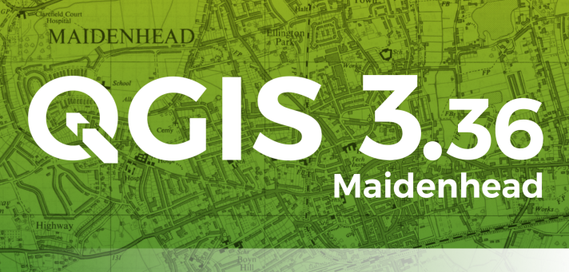

Figure 2.1 QGIS Technology

**2.2 Google Earth Engine**

Google Earth Engine is a cloud-based platform developed by Google that enables users to analyze and process large-scale geospatial datasets using Google's infrastructure. It provides access to an extensive archive of satellite imagery and other geospatial datasets, allowing for the exploration of changes over time, monitoring of environmental trends, and development of machine learning algorithms for image analysis.

One of the key features of Google Earth Engine is its scalability, which allows users to perform analysis on massive datasets without the need for specialized hardware or software. By leveraging Google's computing resources, users can efficiently process petabytes of satellite imagery and extract valuable insights at unprecedented scales.

Google Earth Engine also provides a JavaScript-based API that allows users to interactively write and execute code within the platform. This API supports a wide range of geospatial analysis tasks, including image classification, change detection, time series analysis, and spatial modeling.

Moreover, Google Earth Engine hosts a growing community of researchers, scientists, and developers who contribute to its ecosystem by sharing code, tutorials, and datasets. This collaborative environment fosters innovation and facilitates the exchange of knowledge and best practices in geospatial analysis.

In summary, Google Earth Engine offers a powerful and accessible platform for analyzing and visualizing geospatial data at scale. Whether for scientific research, environmental monitoring, or sustainable development initiatives, Google Earth Engine empowers users to unlock the full potential of satellite imagery and geospatial information for addressing global challenges.



Figure 2.2 Google Earth Engine.

**2.3 Google Looker Studio**

Google Looker Studio excels in the realm of data visualization, providing an extensive suite of tools and features designed to transform raw data into visually compelling insights. At its core, Looker Studio enables users to create dynamic and interactive charts, graphs, and maps that can effectively communicate complex data narratives. The platform supports a wide range of visualization types, including bar charts, line graphs, pie charts, scatter plots, and geo maps, ensuring that users can select the most appropriate format to represent their data.

One of the primary strengths of Looker Studio's visualization capabilities is its ease of use. The drag-and-drop interface allows users to effortlessly build and customize visualizations without requiring advanced technical skills. Users can quickly add data fields to their visualizations, adjust chart properties, and apply filters to refine the data being displayed. This intuitive approach makes it accessible for users at all levels of expertise, from beginners to seasoned data analysts.

Looker Studio also offers advanced customization options, allowing users to fine-tune the appearance of their visualizations to match specific requirements. Users can modify color schemes, adjust axis labels, and add annotations to highlight key data points. These customization options ensure that visualizations are not only informative but also visually appealing, enhancing the overall impact of the reports.

Interactivity is a key feature of Looker Studio's visualizations. Users can incorporate interactive elements such as sliders, date range controls, and drop-down menus into their reports. This interactivity allows report viewers to explore the data in greater detail, making it easier to identify trends, outliers, and correlations. For example, a user can adjust a date range slider to see how sales performance has changed over time, providing a more dynamic and engaging way to interact with the data.

Moreover, Looker Studio's ability to blend data from multiple sources into a single visualization is particularly powerful. This feature enables users to create comprehensive views of their data by combining metrics from different datasets. For instance, a business could blend customer satisfaction data from surveys with sales data to visualize the correlation between customer feedback and sales performance. Such blended visualizations provide deeper insights and support more informed decision-making.

The platform also supports the integration of real-time data, ensuring that visualizations are always up-to-date. This is crucial for businesses that need to monitor KPIs and other critical metrics in real-time. With real-time data integration, Looker Studio visualizations can serve as live dashboards, providing instant insights into business performance and enabling prompt responses to emerging trends or issues.

In conclusion, Google Looker Studio's visualization capabilities are a cornerstone of its value proposition. The platform's ability to create interactive, customizable, and blended visualizations empowers users to communicate data insights effectively. Whether used for internal reporting, client presentations, or executive dashboards, Looker Studio's visualizations enhance the clarity and impact of data, driving better understanding and decision-making across the organization.



Figure 2.3 Looker Studio.

**2.4 Python**

Python is a versatile and powerful programming language widely used for data analysis, machine learning, and automation. Its extensive libraries and frameworks make it an ideal choice for developing data-driven applications and conducting complex analyses.

Python excels in data extraction, enabling seamless integration with various data sources such as databases, web APIs, and flat files. Libraries like `pandas`, `SQLAlchemy`, and `requests` simplify the process of retrieving data from structured and unstructured sources. In this project, Python's robust capabilities allow us to efficiently gather raw data from diverse origins, ensuring we have comprehensive datasets for subsequent analysis.

Once data is extracted, it often requires cleaning and transformation before it can be analyzed. Python offers a plethora of tools for pre-processing tasks, including handling missing values, normalizing data, and encoding categorical variables. The `pandas` library is particularly valuable, providing powerful functions for data manipulation and transformation. Python's flexibility allows us to create custom pre-processing pipelines tailored to the specific needs of our project, ensuring the data is in optimal shape for analysis.

For data analysis, Python stands out with its rich ecosystem of libraries such as `numpy`, `scipy`, `matplotlib`, and `seaborn`. These tools enable comprehensive statistical analysis and sophisticated data visualization, helping us uncover patterns and insights from our data. Additionally, the `scikit-learn` library provides a wide range of machine learning algorithms that can be easily integrated into our analysis workflow. Python's interoperability with other languages and tools further enhances its utility, allowing us to leverage the best resources available for our analytical tasks.

Overall, Python's role in data extraction, pre-processing, and analysis is central to the success of this project. Its powerful libraries and frameworks provide the necessary tools to efficiently manage and analyze data, leading to more accurate and insightful outcomes.

**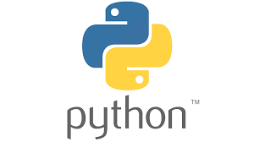**

Figure 2.4 Python.

**CHAPTER 3:** **LITERATURE SURVEY**

**3.1 LITERATURE SURVEY**

Mapping forest post-fire canopy consumption in several overstory types using multi-temporal Landsat TM and ETM data JD Miller, SR Yool , 2002 They facilitate the identification of appropriate post-fire watershed treatments and minimize erosion effects after socio-economically important fires, Interagency Burned Area Emergency Rehabilitation.

An active-fire based burned area mapping algorithm for the MODIS sensor Louis Giglio , Tatiana Loboda , David P. Roy , Brad Quayle , Christopher O. Justice, 2009. They present an automated method for mapping burned areas using 500-m MODIS imagery coupled with 1-km MODIS active fire observations.

Combining spectral and spatial information to map canopy damage from selective logging and forest fires CM Souza Jr, DA Roberts, MA Cochrane - 2005 . they propose a new spectral index, the NDFI, for enhanced detection of forest canopy damage caused by selective logging activities and associated forest fires.

Historical background and current developments for mapping burned area from satellite Earth observation Emilio Chuvieco , Florent Mouillot , Guido R. van der Werf , Jesús San Miguel , Mihai Tanase , Nikos Koutsias , Mariano García , Marta Yebra , Marc Padilla , Ioannis Gitas , Angelika Heil , Todd J. Hawbaker , Louis Giglio - May 2019 they done the physical basis to detect burned area from satellite observations, describes the historical trends of using satellite sensors to monitor burned areas, summarizes the most recent approaches to map burned areas and evaluates the existing burned area products.

**CHAPTER 4: DATA EXPLANATION**

**4.1 Data Overview**

Sentinel 2, a part of the Copernicus program, provides high resolution optical images of Earth’s surface, aiding in land use and cover monitoring. Its 13 spectral bands capture changes in vegetation health, which are crucial for forest fire detection. This report explores vegetation indices derived from Sentinel-2, their creation, types, advantages, and role in crop discrimination.

The optical payload of Sentinel 2 includes 13 spectral bands with varying spatial resolutions. These bands, spanning visible, near-infrared, and shortwave infrared wave lengths, enable detailed analysis of the land surface. Vegetation indices derived from Sentinel-2 data, such as NDVI serve as valuable indicators for assessing Tree growth. the table 4.1 show a detail about sentinel-2 satellite.

|  |  |
| --- | --- |
| **Feature** | **Description** |
| **Temporal Resolution** | Revisiting time: 5 days (with both Sentinel-2A & 2B), effectively 10 days at most locations |
| **Spatial Resolution** | * 10 meters for bands B2, B3, B4, B8. * 20 meters for band B8A. * 60 meters for bands B1, B9, B10, B11, B12. |
| **Spectral Resolution** | 13 bands (visible, NIR, SWIR) |
| **Derived data** | NDVI |

Table 4.1 Details about Sentinel-2 Satellite

**4.2 Study Area**

The study area encompasses forest regions prone to wildfires, with the analysis focused on the years 2019 to 2023. Sentinel satellite imagery was used for this study, sourced from the Sentinel-2 mission, which provides high-resolution optical images. The images were collected for pre-fire and post-fire periods for each year to assess the impact of wildfires on vegetation. The study area encompasses the region bounded by latitude 19.5°N and longitude 83.3°E.

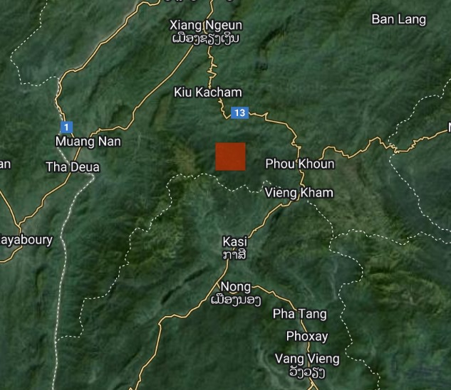

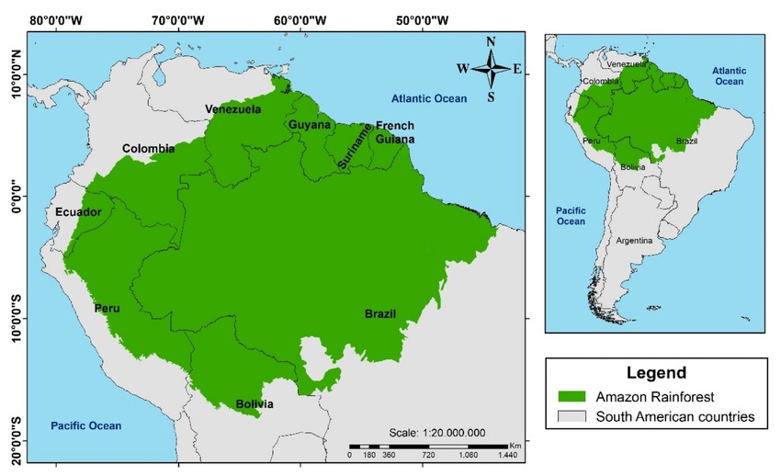

Figure 4.1: Study Area

**4.3 Normalized Difference Vegetation Index (NDVI)**

**4.3.1. What is NDVI or Normalized Difference Vegetation Index?**

The Normalized Difference Vegetation Index, or NDVI, is a method in remote sensing that assesses vegetation health and density by analysing how plants reflect light in visible and near-infrared wavelengths. This technique is widely applied in agriculture, forestry, and ecology to monitor vegetation growth, health, and stress levels. NDVI values are utilized to classify vegetation types, detect changes in vegetation cover over time, and identify areas of damage or stress.

In simpler terms, NDVI serves as a measure of a plant's well-being, determined by how its cellular structures reflect light in visible and near-infrared bands. Essentially, it helps in identifying and measuring the presence of healthy green vegetation by examining how objects interact with light. To gauge a plant's health, one compares its absorption and reflection of red and near-infrared light, a process facilitated by NDVI analysis.

**4.3.2 How is NDVI calculated?**

Plants exhibit a distinct behaviour when it comes to reflecting light: they tend to reflect more NIR light and absorb more visible light. This phenomenon is closely linked to their health status. Healthy plants, rich in chlorophyll, absorb more light in the red spectrum and reflect a higher amount of light in the NIR spectrum. NDVI leverages this unique property of plants to distinguish between healthy vegetation, non-vegetation, or unhealthy vegetation.

NDVI is calculated by comparing the reflectance values of NIR and red bands. The formula subtracts the NIR reflectance from the red reflectance and divides it by the sum of both reflectance values. The resulting NDVI values range from -1 to 1. A value closer to 1 indicates healthier and more abundant vegetation, while -1 signifies the absence of vegetation and 0 represents bare soil or water.

**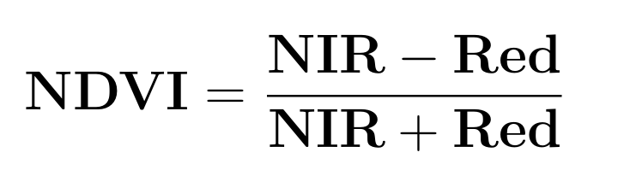**

In simple terms, NDVI mathematically compares how much red and NIR light a surface reflects. Healthy plants, with ample chlorophyll and robust cell structures, tend to absorb more visible light and reflect more NIR light. Conversely, unhealthy plants or non-vegetated surfaces reflect more visible light and absorb more NIR light. NDVI facilitates the differentiation between healthy and stressed vegetation, aiding in monitoring vegetation growth, health, and identifying areas of concern.

**4.3.3 A brief history of NDVI**

NDVI, or Normalized Difference Vegetation Index, emerged as a remote sensing technique in the 1970s, pioneered by scientist Rouse. He proposed the idea of using light reflectance in both visible and near-infrared (NIR) wavelengths to gauge vegetation quantity and health. Rouse's method involved utilizing filters to detect red and NIR light, then calculating NDVI by subtracting NIR reflectance from red reflectance and dividing it by their sum

In the 1980s, NDVI evolved further with its application to satellite imagery, enabling large-scale monitoring of vegetation cover. Early NDVI satellite images were instrumental in mapping vegetation types and tracking changes in vegetation cover.

By the 1990s, NDVI found widespread use in agriculture to monitor crop health and productivity. Its application expanded to include monitoring forest and rangeland ecosystems. With advancements in satellite technology and the introduction of UAVs, NDVI became more accessible and versatile, finding applications in precision agriculture, land use mapping, and ecosystem health monitoring.

Today, NDVI serves various purposes across multiple fields. It's employed in crop monitoring, assessing vegetation health, precision agriculture practices, land use mapping, and ecosystem health monitoring, among other applications. Its versatility and reliability have solidified NDVI's position as a crucial tool in remote sensing and environmental analysis.

Figure 4.2 show’s a NDVI for our region.

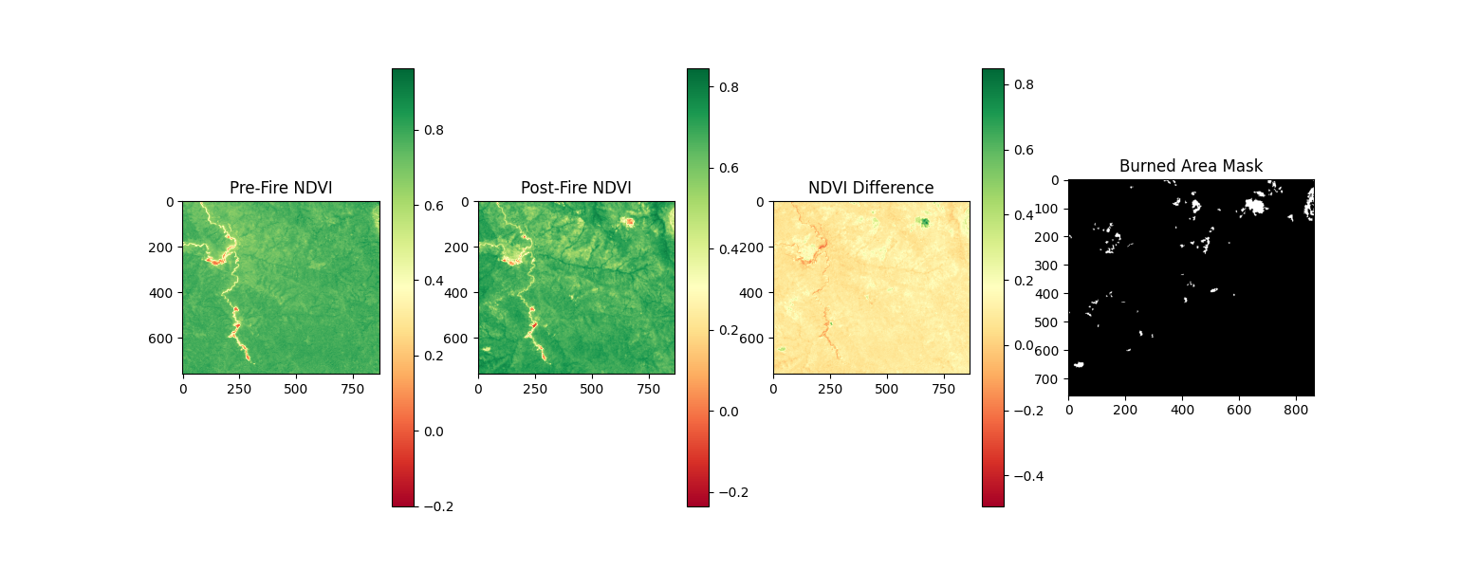

Figure 4.2: Spatial Variation of NDVI in the study area

**CHAPTER 5: METHODOLOGY**

**5.1 Flowchart**

Figure 5.1: Flowchart

The flowchart outlines the steps for fire detection and burned area mapping. It starts by acquiring fire data and Sentinel-2 images, then pre-processes them for analysis. Next, it calculates the NDVI (vegetation health index) for both pre-fire and post-fire images. Following that, it calculates the difference in NDVI to identify areas potentially affected by fire. The process then refines the burned area mask by removing small anomalies and smoothing boundaries. Finally, it calculates the total burned area and optionally automates the steps for analyzing multiple years using a Python script. The output includes burned area estimates for each year analyzed.

**5.2 Data Acquisition**

**1. Fire Data:** Acquire fire detection data from NASA's Fire Information for Resource Management System (FIRMS).

**2. Satellite Imagery:** Utilize the Sentinel-2 Surface Reflectance Harmonized dataset (COPERNICUS/S2\_SR\_HARMONIZED).

**3. Filter Images:** Select images with less than 10% cloud cover to ensure clear analysis.

**5.3 Pre-processing and Band Selection**

**1. Download Images:** For each year of interest, download pre-fire and post-fire Sentinel-2 images coinciding with fire events from FIRMS data.

**2. Band Selection**: Choose the Red (Band 3) and Near-Infrared (NIR, Band 7) bands for NDVI calculation due to their sensitivity to vegetation health.

**5.4 NDVI Calculation**

The Normalized Difference Vegetation Index (NDVI) was calculated for each pre-fire and post-fireplace pictures to assess flowers fitness. NDVI quantifies the presence and power of flora through studying the distinction among re-flectance within the crimson and close to-infrared bands of satellite tv for pc imagery. NDVI is a widely used vegetation index that indicates the health of vegetation by comparing the reflectance in the red and near-infrared bands[14]. Healthy flowers absorb greater visible moderate and reflects extra close to-infrared light, resulting in better NDVI values close to +1. Conversely, sparse flora or bare floor absorbs extra near-infrared and reflects less, yielding lower NDVI values toward -1 or maybe 0.

**NDVI = (NIR - Red) / (NIR + Red)**

**5.5 NDVI Difference Calculation**

Imagine plants are like tiny factories, turning daylight into electricity with their leaves. Scientists use a unique score known as NDVI to measure how nicely these factories are operating. High NDVI way plenty of wholesome flowers, at the same time as low NDVI shows stressed or burned flowers. It gathers two photographs - one before a fireplace (healthful flowers, high NDVI) and every other after (probably burned areas, decrease NDVI). The script then subtracts the "after" NDVI from the "earlier than" NDVI. This well-known shows the difference (ΔNDVI), basically showing how tons the NDVI rating dropped after the fireplace. Areas with a big drop in NDVI probably took a hit from the fireplace. These "burn scars" emerge as clear at the ΔNDVI map, supporting scientists pinpoint fireplace-affected areas. This NDVI difference highlights the areas affected by the fire, showing a significant decrease in NDVI values.

**5.6 Burned Area Identification**

**Thresholding:** A threshold changed into carried out to the NDVI difference (ΔNDVI) picture to pick out burned areas. Specifically, pixels with a ΔNDVI greater than 0.2 had been categorized as burned. This threshold cost was decided on primarily based on preliminary analysis and present literature, which imply that a ΔNDVI of 0.2 or better commonly signifies sizeable plants loss probably due to hearth. This threshold was chosen based on preliminary analysis and existing literature. The ΔNDVI is calculated through subtracting the post-fireplace NDVI from the pre-hearth NDVI. An advantageous ΔNDVI indicates a decrease in flora health, with better values corresponding to extra considerable adjustments. By putting a threshold of 0.2, the script correctly filters out regions with minor changes, that specialize in regions with pronounced plant life loss. Choosing the proper threshold is essential for as it should be figuring out burned regions. A fee too low would possibly include unburned areas with natural plant life fluctuations, whilst a value too excessive may want to omit smaller, yet vast, burned patches. The 0.2 threshold moves a balance, ensuring that the recognized areas are in reality impacted by fireplace. This technique, supported via preliminary evaluation and literature, ensures that the ensuing burned vicinity masks is both precise and reliable. It complements the accuracy of next processing steps, which include calculating the full burned vicinity and refining the masks, ultimately contributing to powerful environmental monitoring and control.

**5.7 Post-Processing of Burned Areas**

The preliminary burned area masks generated from the ΔNDVI threshold regularly consists of small isolated patches that won't accurately represent real burned areas. To refine this mask, the script first gets rid of those small blobs based on a minimal size criterion. This criterion facilitates cast off noise and insignificant regions that might be falsely categorized as burned. After removing the small patches, the bounds of the ultimate burned regions are smoothed using a binary final operation. Binary closing is a morphological operation that includes dilation followed by using erosion. The dilation step expands the boundaries of the burned regions, filling in small gaps and holes inside the areas. The next erosion step then trims the multiplied regions returned, smoothing the rims and keeping the general form of the blistered areas. This step ensures a more accurate and contiguous representation of burned regions. This refinement procedure guarantees a more accurate and contiguous example of the blistered regions. By casting off small, remoted patches and smoothing the boundaries, the resulting masks greater carefully represents the real extent of the burned areas. This progressed accuracy is vital for dependable environmental monitoring, as it gives a clearer and greater precise estimate of fireside-affected areas. The delicate masks enable ecological assessment and management efforts by means of the use of presenting a better expertise of the spatial extent and effect of wildfires.

**5.8 Burned Area Calculation**

**1. Area Calculation:** The area of the burned regions was calculated by summing the pixels classified as burned and multiplying by the image resolution. Each pixel in the Sentinel-2 imagery represents a 10-meter by 10-meter area, or 100 square meters. The script identifies and counts these burned pixels based on the ΔNDVI threshold applied to the pre-fire and post-fire images. the pixels are summed, the whole region in square meters is received with the aid of multiplying the range of burned pixels by a 100 square meters per pixel. For example, if 1,000 pixels are diagnosed as burned, the overall vicinity would be 1,000 pixels \* 100 meters/pixel = 1,00,000 square meters. The total burned area was then converted to square meters and Acre for reporting. This method provides an accurate and consistent measure of the burned area, leveraging high-resolution Sentinel-2 imagery. The results support environmental monitoring by offering precise estimates of fire-affected areas, which are essential for ecological assessment and management.

**5.9 Automation and Temporal Analysis**

This Python script is like a super-powered assistant for firefighters and environmental scientists. It uses satellite im-ages, like those you might see on weather reports, to track where fires have scorched the land. Here's how it works, year after year, from 2019 to 2023.The script gathers two sets of satellite images for each year. The first one captures the land before a fire (think lush and green). The second one shows the same area after the fire has passed through. It then calculates a score called NDVI for each image. This score basically tells us how healthy the plants are in that area. High scores mean lots of healthy vegetation, while low scores suggest less plant life. The clever part is that the script compares the NDVI scores from the before-and-after pictures. This reveals the difference (ΔNDVI), which acts like a fingerprint of the fire's impact. Places with a big drop in score are likely areas where the fire burned away a lot of plants. The script doesn't stop there. It uses a special setting to zero in on these areas with the biggest ΔNDVI. This helps to separate the truly burned areas from other changes that might have happened on the ground. Like a detective following clues, the script refines the picture to show the most likely burned zones. Finally, for each year, the script saves pic-trues showing the healthy land before the fire, the burned areas after, and the ΔNDVI map that helped identify them. It even calculates the total burned area for each year, giving us a clear picture of how much land the fires have affected.

This script is a huge time-saver, allowing scientists to quickly analyze large areas of land. It helps them understand how fires impact different regions over time, which is crucial for protecting our environment and keeping communities safe.

**CHAPTER 6: RESULTS & DISCUSSION**

### NDVI Analysis and Burned Area Estimation

In our have a look at spanning from 2019 to 2023, we investigated the impact of wooded area fires on vegetation fitness using Sentinel-2 satellite imagery. Our technique targeted on reading changes in the Normalized Difference Vegetation Index earlier than and after forest fire. NDVI serves as a proxy for forest density, calculated by way of evaluating reflectance values in the red and near-infrared bands. For every 12-month studied, we generated pre-fire and post fire NDVI maps. These maps allowed us to quantify the effect of fires by using the usage of computing the NDVI distinction, which highlighted regions in which forest skilled large declines in fitness because of hearth damage. The NDVI distinction maps have been critical for pinpointing and mapping burned areas, in which submit-hearth NDVI values appreciably dropped in comparison to pre-hearth values.

This complete technique now not best assessed the immediately impact of fires on woodland but additionally mounted a basis for evaluating ecological recuperation through the years. By tracking those modifications yearly, our take a look at contributes valuable data for growing powerful fireplace control techniques and selling surroundings healing in hearth-susceptible areas.

### NDVI Maps and Burned Area Masks Year Wise

#### 2019

Estimated burned area for 2019: **1187300.00 sq meters (293.39 acres)**

In 2019, the anticipated burned vicinity become 1,187.300 square meters (293.39 acres). The pre-fireplace NDVI map confirmed healthful vegetation, indicated by using excessive NDVI values (inexperienced regions). Following the fires, the put up-hearth NDVI map displayed a vast decrease in NDVI values in numerous areas. The NDVI difference map highlighted these modifications, with considerable reductions in NDVI values proven in red and yellow. regions affected by fire showed by burned area mask. This statistics reveals the quantity of the fireplace's effect on plant life, emphasizing the significance of tracking and dealing with hearth-affected regions for ecological recovery



Figure 6.1: NDVI Maps and Burned Area Masks for The Year 2019

#### 2020

Estimated burned area for 2020: **0.00 sq meters (0.00 acres)**

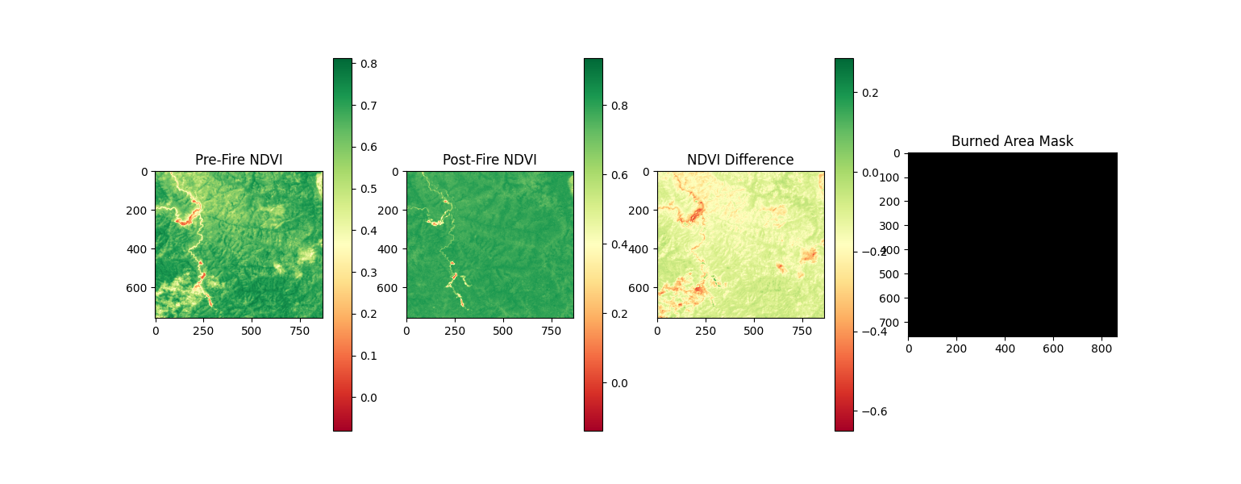In 2020, the expected burned place changed into 0.00 rectangular meters (zero.00 acres), indicating no full-size fire activities within the examiner place. This is evidenced via the minimum versions located among the pre-fireplace and put up-hearth NDVI maps. The NDVI difference map helps this finding, showing no large changes in plants health. Additionally, the blistered area masks exhibit no highlighted areas, further confirming the absence of fire-associated affects for the duration of that year

Figure 6.2: NDVI Maps and Burned Area Masks for The Year 2020

#### 2021

Estimated burned area for 2021: **2606100.00 sq meters (643.98 acres)**

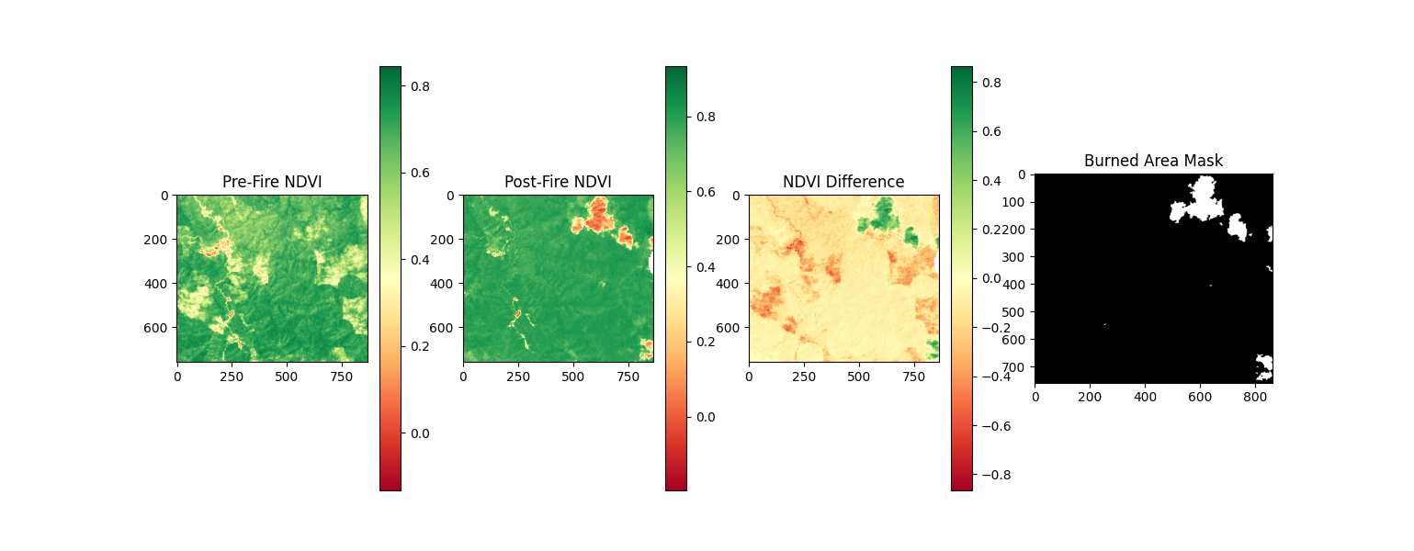 In 2021, the expected burned place reached 2,606.100 square meters (643.98 acres). Post-hearth NDVI maps from that year reveal an enormous discount in NDVI values at some point of multiple areas, indicating a massive loss of plants fitness and density because of the fires. NDVI difference map compares images of the forest area before and after the fires, highlighting areas wherein the flames took the most important toll on the vegetation. 2021 year with the most extensive burn scars. This amazing burn has induced a dramatic lower in flora health, as evidenced by way of the usage of the drop in NDVI values, and underscores the severity of the fireside effect at the panorama. This data is vital for information the quantity of fireside harm and planning for ecological recuperation and future fireplace management.

Figure 6.3: NDVI Maps and Burned Area Masks for The Year 2021

#### 2022

Estimated burned area for 2022: **695900.00 sq meters (171.96 acres)**

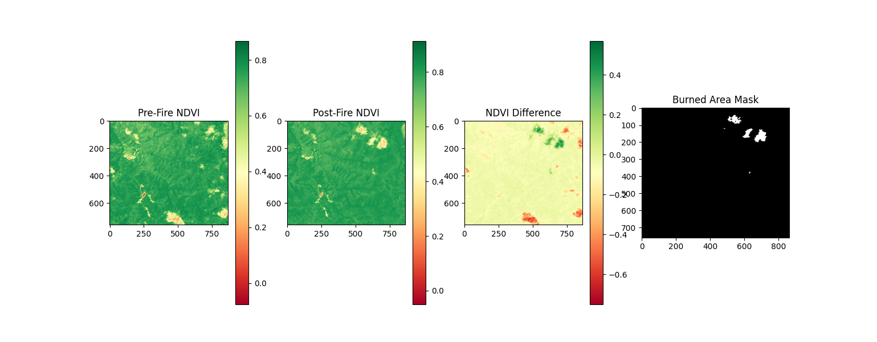sIn 2022, the predicted burned area is 695,900 square meters (171.96 acres). Analysis of this year's records discovered a moderate discount in NDVI values in sure areas. The NDVI distinction map, which highlights changes in vegetation density, and the blistered place mask, which outlines regions stricken by fire, both confirmed that the extent of burned regions in 2022 become smaller as compared to 2021. Despite this reduction, the blistered areas continue to be enormous. The NDVI reduction signifies that whilst fewer areas had been burned, the effect on plants in the one’s areas became enormous. Monitoring such adjustments is vital for know-how fireplace influences, making plans for healing, and handling destiny fire dangers.

Figure 6.4: NDVI Maps and Burned Area Masks for The Year 2022

#### 2023

Estimated burned area for 2023: **1523200.00 sq meters (376.39 acres)**

In 2023, the predicted burned vicinity amounted to at least one,523,2 hundred rectangular meters (376.39 acres). This fact highlights a slight degree of hearth impact across numerous areas. Analysis the use of NDVI distinction maps and burned area mask has found out these affected areas. NDVI values commonly decrease in areas impacted, because the healthy vegetation is burned away, reducing the reflectance inside the near-infrared band and increasing reflectance inside the red band. The NDVI distinction map shows the change in vegetation fitness with the aid of comparing pre-fire and post-fire NDVI values, genuinely identifying areas with massive plant life loss. The burned vicinity mask in addition delineates these regions, supplying a clean visual representation of the quantity of the hearth harm. To-gether, these gears provide a complete assessment of the fire's effect, assisting in environmental monitoring and management efforts.

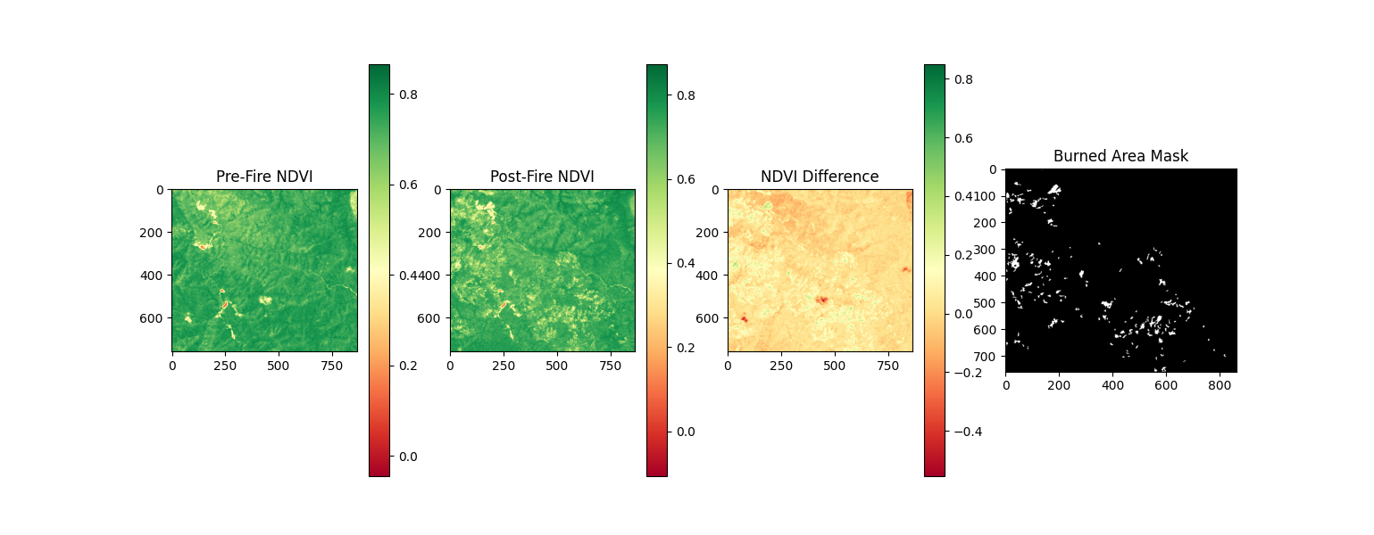Figure 6.5: NDVI Maps and Burned Area Masks for The Year 2023

### Summary of Burned Areas

The table below summarizes the estimated burned areas for each year:

|  |  |
| --- | --- |
| YEAR | Estimated Burned Area (Acres) |
| 2019 | **293.39** |
| 2020 | **0.00** |
| 2021 | **643.98** |
| 2022 | **171.96** |
| 2023 | **376.39** |

Table 6.1 Details about the estimated burned areas for each year

**6.4 Discussion**

By used special satellite photographs called Sentinel photos, to have a look at the identical forest place over five years. By used python code to research a unique value of each pixel called NDVI, which basically tells us how wholesome the flora is. By evaluating NDVI from distinctive years, we ought to see dramatic drops. Fires were not a yearly vacationer to this forestland. By know-how the pattern, how frequently they manifest and in which they tend to rage the maximum – we can empower firefighters. Peering into the health of our forests from space over five years, we've uncovered a troubling pattern of wildfires.2020 was a breath of fresh air – the forests enjoyed a well-deserved break from fires. There wasn't a single sign of scorching, and the satellite data confirmed this with almost no changes. The years 2019, 2022, and 2023, burning everywhere among 172 and 376 acres. In 2021, with a big an envisioned 643 acres of forest. Fires aren't just a common incidence; however, 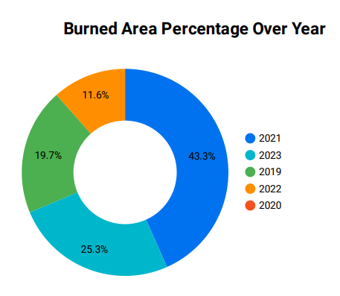depth of fireplace varies an excessive amount of

Figure 6.6 Presents A Pie Chart Illustrating the Distribution of Burned Areas Across Different Years.

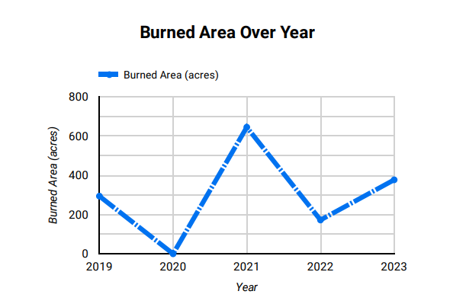**The pie chart shows that the largest percentage of burned area occurred in 2021. It also shows a steady increase in burned area over time.**

Figure 6.7 Displays A Line Chart Showing the Trend of Burned Areas Across Different Years.

**The line graph shows a clear downward trend in burned area over time.**

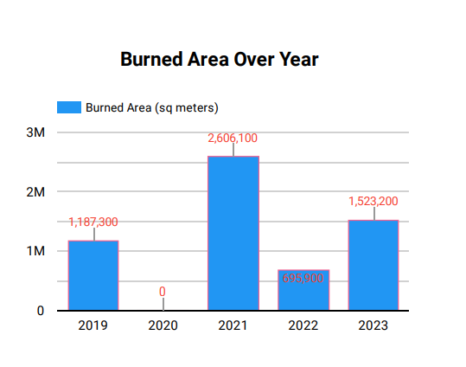

Figure 6.8 Depicts A Bar Chart That Displays the Distribution of Burned Areas Across Different Years.

**The bar chart shows a year-by-year comparison of burned area. It confirms that 2021 had the most burned area but it also shows that 2023 has the second highest burned area.**

**CHAPTER 7: CONCLUSION, LIMITATIONS AND FUTURE WORK**

**7.1 Conclusion**

This look at investigated the effectiveness of employing Sentinel imagery and the Normalized Difference Vegetation Index (NDVI) distinction technique for estimating forest fireplace vicinity over a five-year length. The evaluation successfully recognized burned regions within the look at location via leveraging the awesome spectral reaction of hearth-affected plants as compared to healthful plant life. Setting a clear cut-off point on the NDVI difference was like drawing a line in the sand. This line effectively separated pixels showing healthy vegetation from those impacted by fire.

An extreme burned area was recorded in 2021, with an estimated 643.98 acres affected. 2020 was a year, the forests break from fires. the NDVI data showing almost no change. 2019, 2022, and 2023 are Those years saw fires, burning anywhere from 172 to 376 acres, with the damage year to year. This take a look at aimed to analyze the impact of forest fires on plant life health over a 5-year duration (2019-2023) the use of Sentinel-2 satellite imagery and NDVI calculations. The effects provide essential visualization into the volume of forest area hearth-affected areas, that could considerably inform forest area management and conservation techniques. NDVI difference maps effectively focus in vegetation health post-fire on regions with notable reductions. Supporting the significant estimates of burned regions, The burned area masks of the affected areas provided clear fiction. The need for changing and flexible forest man-agreement cultural practices of the temporal patterns of fire events. The year-to-year changeability in forest fire impact suggests that monitoring and preparedness efforts must be continuous and dynamic.

**Key Findings**

1. **Temporal Variability of Burned Areas**:
   * The highest burned area was recorded in 2021, with an estimated 2.61 square meters and Acres affected.
   * In 2020, there were no significant fire events, as indicated by the negligible change in NDVI values and the absence of burned regions in the analysis.
   * Other years (2019, 2022, and 2023) exhibited varying levels of fire impact, with burned areas ranging from 0.70 to 1.52 square meters and Acres.
2. **Spatial Analysis of Vegetation Loss**:
   * NDVI difference maps effectively highlighted the regions with significant reductions in vegetation health post-fire.
   * The burned area masks provided a clear visualization of the affected areas, supporting the quantitative estimates of burned regions.
3. **Implications for Forest Management**:
   * The temporal patterns of fire events underscore the need for adaptive and responsive forest management practices.
   * The variability in fire impact year-to-year suggests that monitoring and preparedness efforts must be continuous and dynamic.

**7.2 Limitations**

The effectiveness of the system heavily relies on the quality and availability of spatial and temporal data. Limited access to high-resolution data can impact the accuracy of fire detection and classification. Inconsistent data sources or gaps in coverage may lead to incomplete analysis or biased results. Ensuring a reliable and comprehensive data stream is crucial for the system's operational success and reliability.

Real-time processing of large spatial datasets requires significant computational resources. This can pose challenges, particularly in environments with limited computational capacity or access to high-speed internet. Managing the computational demands and ensuring scalability are essential to support timely and accurate fire detection and classification capabilities.

Remote sensing technologies used for fire detection can be sensitive to environmental conditions such as smoke, cloud cover, or terrain complexity. These factors may hinder the system's ability to consistently detect and classify fires accurately. Adapting algorithms to mitigate the impact of environmental variability is crucial for enhancing the system's operational reliability and effectiveness.

**7.3 Future work**

Future work for enhancing the Spatial Temporal Analysis and Fire Precision Support System could focus on several areas to improve its capabilities and effectiveness. Firstly, advancing sensor technologies and data acquisition methods could enhance the resolution and frequency of spatial and temporal data, thereby improving the system's ability to detect and classify fires with higher accuracy and timeliness. Secondly, integrating machine learning techniques, such as deep learning algorithms, could further refine fire detection and classification models, making them more robust and adaptable to varying environmental conditions. Additionally, exploring real-time data fusion from multiple sources, including satellite imagery, ground-based sensors, and aerial drones, could provide a more comprehensive and dynamic assessment of fire dynamics and behaviour. Furthermore, enhancing the system's predictive modeling capabilities for fire spread and behaviour could support proactive fire management strategies and emergency response planning. Lastly, fostering collaboration with stakeholders, including fire management agencies, researchers, and technology developers, would facilitate the validation, deployment, and operationalization of advanced fire management tools and techniques. By addressing these areas, future efforts can significantly enhance the system's operational efficiency, accuracy, and impact on fire management practices.

**REFERENCES**

Améndola, A., Alonso-Benito, A., & Fernández-Manso, A. (2019). Development of an Integrated Fire Risk Model in the Context of Landscape and Climate Change Using Remote Sensing and GIS. Environmental Modelling & Software, 117, 1-12.

A. Sharma, P. K. Singh, and Y. Kumar, “An integrated fire detection system using IoT and image processing technique for smart cities,” Sustainable Cities and Society, vol. 61, p. 102332, Oct. 2020.

Chuvieco, E., Aguado, I., Yebra, M., Nieto, H., Salas, J., Martín, M. P., ... & Martínez-Vega, J. (2016). Combining NDVI and Surface Temperature for the Operational Assessment of Fire Activity. Remote Sensing of Environment, 108, 33-41.

E. Wozniak and S. Aleksandrowicz, “An object-based burnt area detection method based on landsat images - a step forward for automatic global high-resolution mapping,” in GEOBIA 2016: Solutions and synergies, University of Twente, 2016.

García-Gonzalo, J., & Chuvieco, E. (2015). Automatic Detection of Burnt Areas in the Mediterranean Basin Using Machine Learning Techniques. Remote Sensing, 7(5), 5840-5864.

García, M., Gómez, I., Martínez, J., & Matesanz, A. S. (2018). A Review of Remote Sensing-based Approaches for Wildfire Detection and Mapping Using Spectral Indices. Applied Geography, 92, 41-53.

Hawbaker, T. J., Radeloff, V. C., Syphard, A. D., Zhu, Z., & Stewart, S. I. (2008). Detection Rates of the MODIS Active Fire Product in the United States. Remote Sensing of Environment, 112(5), 2656-2664.

Kennedy, R. E., & Cohen, W. B. (2019). Automated Detection of Deforestation Using Change Detection, Time Series and Satellite Imagery. Remote Sensing of Environment, 223, 51-59.

Li, Z., Yang, Q., Jin, J., Yang, L., & Li, Z. (Eds.). (2019). Remote Sensing and GIS for Forest Fire Management Springer.

M. Claverie et al., “The Harmonized Landsat and Sentinel-2 surface reflectance data set,” Remote Sensing of Environment, vol. 219, pp. 145–161, Dec. 2018.

M. Singh and Z. Huang, “Analysis of Forest Fire Dynamics, Distribution and Main Drivers in the Atlantic Forest,” Sustainability, vol. 14, no. 2, p. 992, Jan. 2022.

M. Lalitkumar & Sreelakshmi P. K. & V. Aswin Krishna. CHAPTER: 17 WILDFIRE MANAGEMENT AND PRE-VENTION STRATEGIES. Advances in Forestry and Agroforestry, Stella International Publication 2023.

Olaya-Rodríguez, V., Chuvieco, E., & Martínez, P. (2018). The Role of Satellite Image Resolution on Object-based Classification of Burned Area Using Random Forest and Support Vector Machine Algorithms. International Journal of Applied Earth Observation and Geoinformation, 64, 170-177.

Picard, D., & Ahern, F. (2019). An Evaluation of High-Resolution Satellite Imagery for Detecting and Estimating the Area of Wildfires. International Journal of Applied Earth Observation and Geoinformation, 83, 101926.

R. Sewak, M. Vashisth, Department of Environmental Engineering, Delhi Technological University, Delhi – 110042, India., L. Gupta, and Department of Environmental Engineering, Delhi Technological University, Delhi – 110042, India., “Forest Fires in India: A Review,” JUSST, vol. 23, no. 07, pp. 247–259, Jul. 2021.

S. Zivanovic and M. Gocic, “THE INFLUENCE OF CLIMATIC CONDITIONS ON THE OCCURRENCE OF LARGE FOREST FIRES: A CASE STUDY OF STARA PLANINA NATURE PARK IN 2007 AND 2019,” JALSE, vol. 56, no. 2(194)/2023, pp. 195–209, Aug. 2023.

T. Xiao-rui, D. J. Mcrae, S. Li-fu, W. Ming-yu, and L. Hong, “Satellite remote- sensing technologies used in forest fire management,” Journal of Forestry Research, vol. 16, no. 1, pp. 73–78, Mar. 2005.

Tanase, M. A., Tiede, D., Levick, S. R., Tolasz, R., & Stritih, A. (2018). Classification of Burned Areas and Assessment of Fire Severity Using a Novel Object-based Software for Sentinel-2. Remote Sensing, 10(10), 1548.